Experiment 7

# Student Name: Deepak Saini UID: 20BCS4066 Branch: 20BCC1 Section/Group: A

**Semester: 5th Date of Performance: 27-10-22 Subject Name: Computer Network Lab Subject Code: 20CSP-342**

# 1. Aim/Overview of the practical:

Implement Router as DHCP server that can serve multiple VLAN's.

1. Use 3 VLANS HR, SALES, IT
2. Implement Router as DHCP server
3. Communicate among all the VLANs
4. **Requirements:**

PC, Cisco Packet Tracer.

# Theory:

**Virtual Local Area Network:** Virtual LAN (VLAN) is a concept in which we can divide the devices logically on data Link Layer i.e. (Layer2). Generally, Network Layer (layer 3) devices divides broadcast domain and each broadcast domain can be divided by switches using the concept of VLAN.A broadcast domain is a network segment in which if a device broadcast a packet, then all the devices in the same network will receive it. However, due to limitations of switches packets don’t send outside the broadcast network. To forward out the packets to different VLAN (from one VLAN to another) or broadcast domain, inter VLAN routing is needed. Through VLAN, different small size sub networks are created which are comparatively easy to handle.

* + A **DHCP Server** is a network server that automatically provides and assigns IP addresses, default gateways and other network parameters to client devices.
  + **Without it**, the network administrator must manually set up every client that joins the network, which can be cumbersome, especially in large networks

# Steps for experiment:



1. Select 6 end devices.
2. Now click on network devices and select 1 switch (Switch-2960).
3. Connect all the 4 PCs to the switch with the help of Auto Connect cable/ Copper straight through cable.
4. Now draw 3 regions to create difference between the PCs that is assigned to different departments.
5. Click on switch and move to CLI for the configuration of VLAN.
6. Configure the Switch and Router with the commands below.



sw tch enable

sw tch conf gure term nal sw tch (conf g) vlan 10

sw tch(conf g-vlan) name HR sw tch (conf g) vlan 20

sw tch(conf g-vlan) name SALES sw tch (conf g) vlan 30

sw tch(conf g-vlan) name IT

Sw tch(conf g) nt range fa0/1-2

Sw tch(conf g- f-range) sw tchport mode Access

Sw tch(conf g- f-range) sw tchport access vlan 10 Sw tch(conf g- f-range) ex t

Sw tch(conf g- f) sw tchport mode Trunk

|  |  |  |  |  |  |  |
| --- | --- | --- | --- | --- | --- | --- |
| Sw  Sw | tch(conf  tch(conf | g)  g- | nt fa0/3-4  f-range) sw | tchport | mode Access |  |
| Sw Sw | tch(conf tch(conf | g-  g- | f-range) sw f-range) ex | tchport t | access vlan | 20 |
| Sw Sw | tch(conf tch(conf | g)  g- | nt fa0/5-6 f-range) sw | tchport | mode Access |  |
| Sw Sw | tch(conf tch(conf | g-  g- | f-range) sw f-range) ex | tchport t | access vlan | 30 |
| Sw | tch(conf | g) | nt fa0/7 |  |  |  |



Router>en Router conf g t

Router(conf g) nt fa0/0 Router(conf g- f) no shutdown Router(conf g- f) nt fa 0/0.10 Router(conf g-sub f)

Router(conf g-sub f) encapsulat on dot1q 10 Router(conf g-sub f) p add 10.0.0.1 255.255.255.192 Router(conf g-sub f) nt fa 0/0.20

Router(conf g-sub f) encapsulat on dot1q 20 Router(conf g-sub f) p add 10.0.0.65 255.255.255.192 Router(conf g-sub f) nt fa 0/0.30

Router(conf g-sub f) encapsulat on dot1q 30 Router(conf g-sub f) p add 10.0.0.129 255.255.255.192 Router(conf g-sub f) ex t

Router(conf g) p dhcp pool VLAN10

Router(dhcp-conf g) network 10.0.0.0 255.255.255.192 Router(dhcp-conf g) default-router 10.0.0.1 Router(dhcp-conf g) p dhcp excluded-address 10.0.0.1 Router(conf g) p dhcp pool VLAN20

Router(dhcp-conf g) p dhcp pool VLAN20

Router(dhcp-conf g) network 10.0.0.64 255.255.255.192 Router(dhcp-conf g) default-router 10.0.0.65 Router(dhcp-conf g) p dhcp excluded-address 10.0.0.65 Router(conf g) p dhcp pool VLAN30

Router(dhcp-conf g) network 10.0.0.128 255.255.255.192 Router(dhcp-conf g) default-router 10.0.0.129 Router(dhcp-conf g) p dhcp excluded-address 10.0.0.129 Router(conf g) ex t

Router sh p dhcp pool

# Result/Output:

Connect all the devices

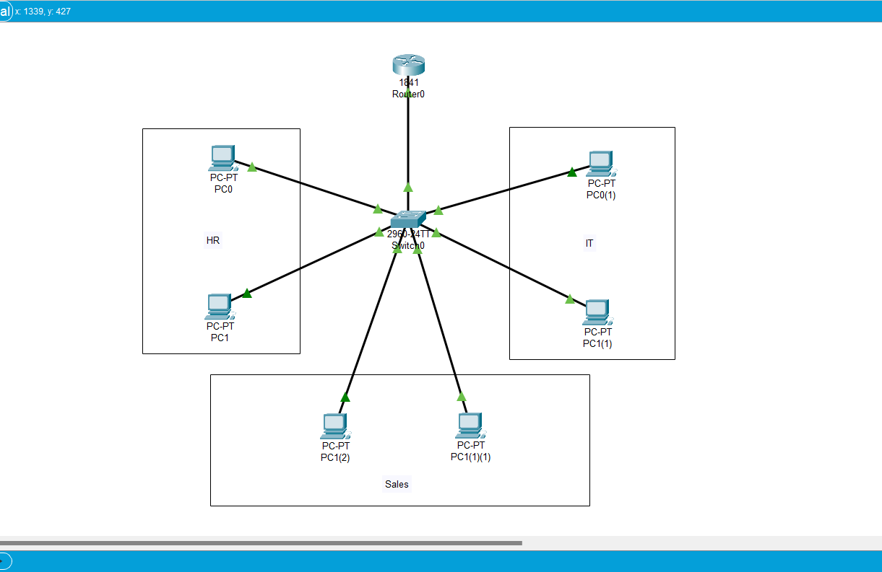

Enable dhcp in every end device. It will automatically assign IP address and gateway.

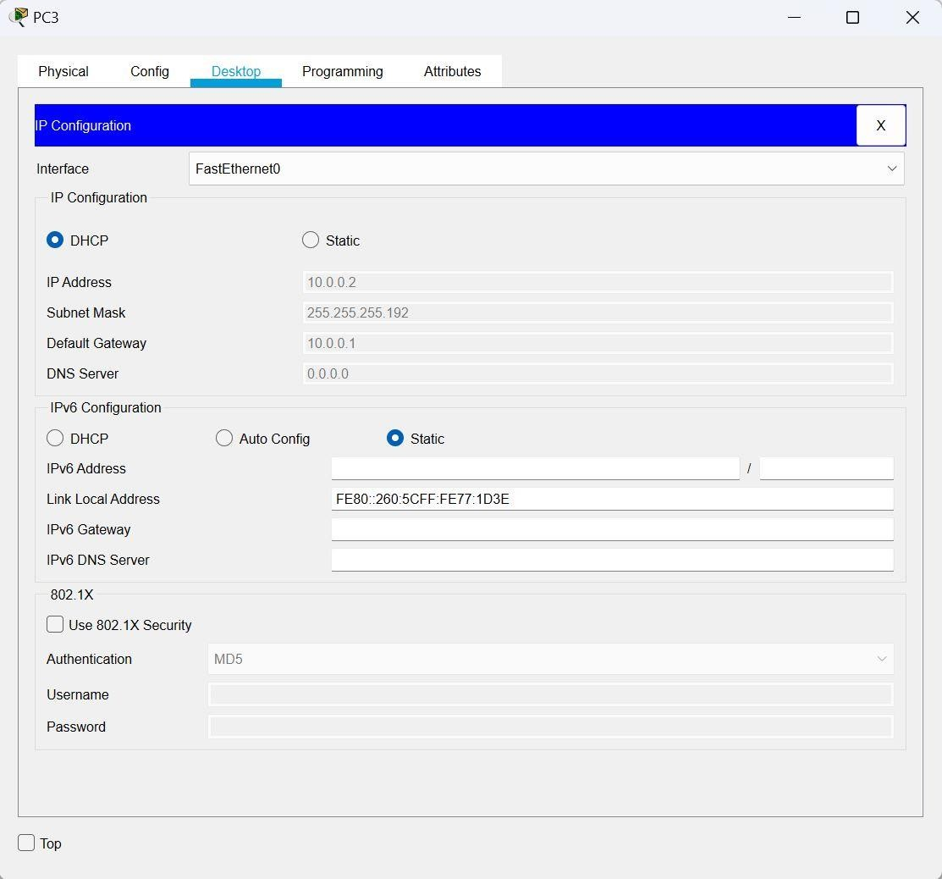

Configured the Switch with given commands

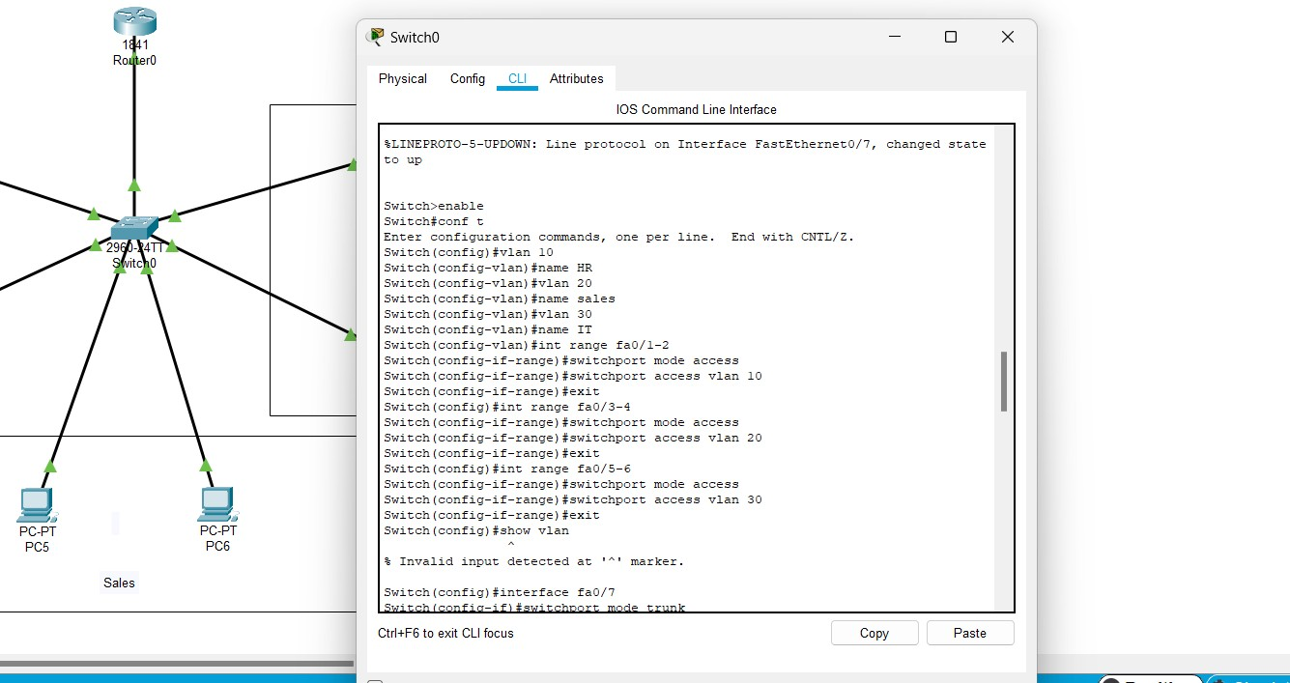

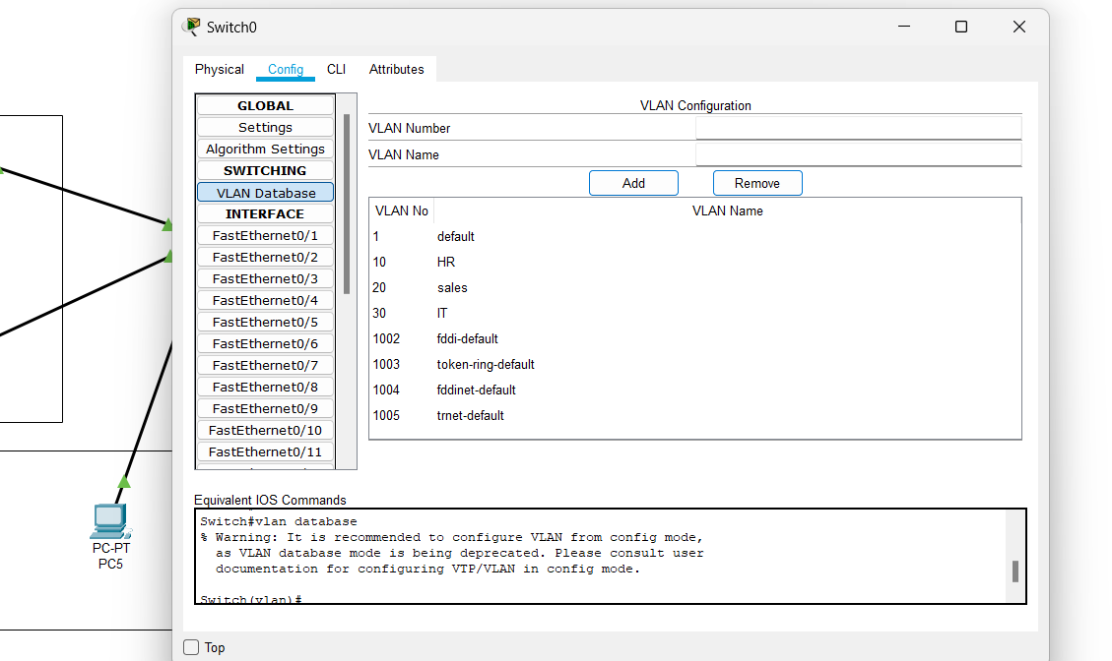

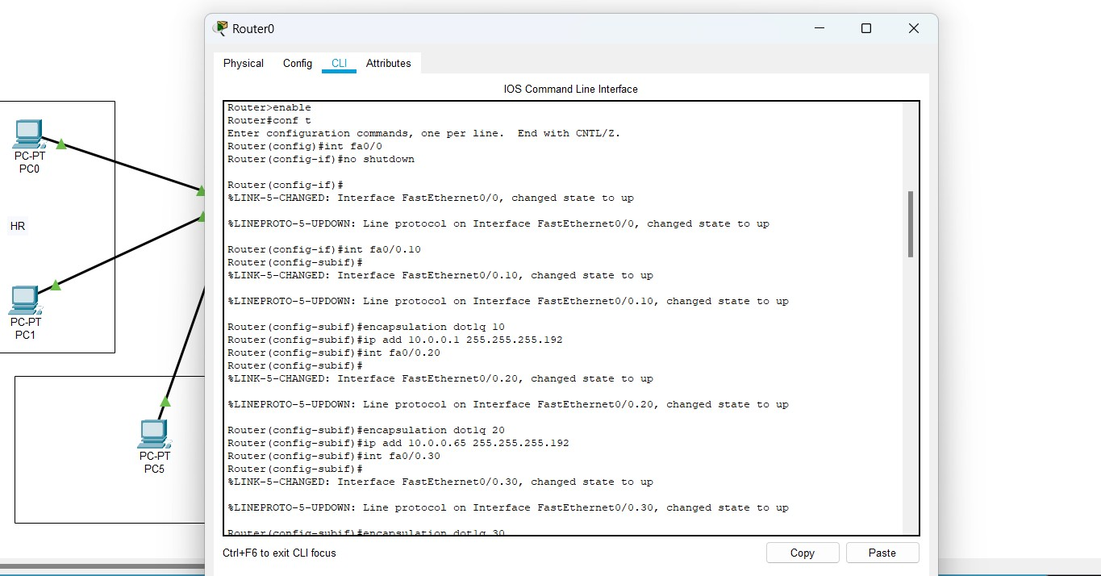Configured the router with given commands to enable VLAN and as DHCP server

Ping the message with the help of ‘ping’ command on Command Prompt

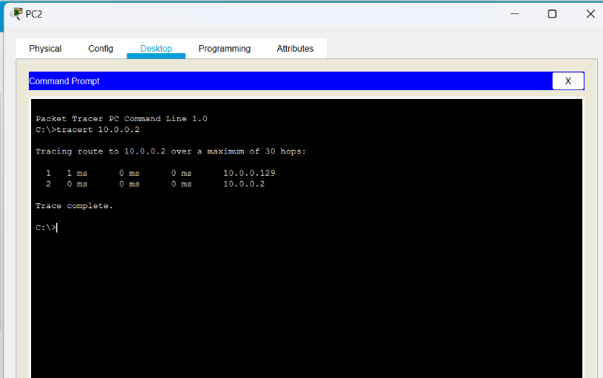

Used command ‘tracert’ to route the path of communication between two end devices

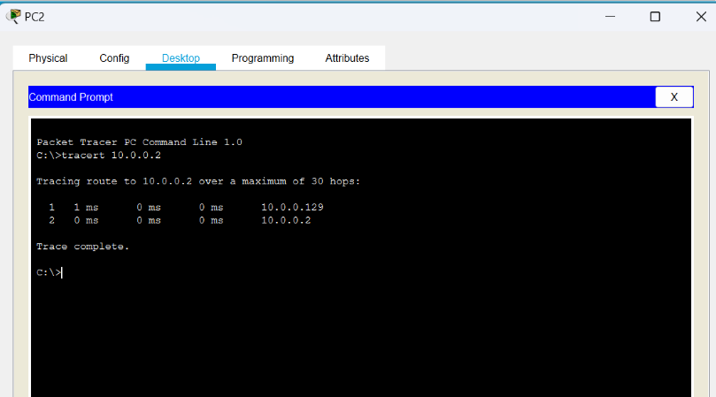

# Learning outcomes (What I have learnt):

* Leant how VLAN is created using simple connection.
* Learnt that how a router can be used as a dhcp server with the help of certain commands.
* How to troubleshoot the network.
* Learnt to route the different networks.

**Evaluation Grid (To be created as per the SOP and Assessment guidelines by the faculty):**

|  |  |  |  |
| --- | --- | --- | --- |
| Sr. No. | Parameters | Marks Obtained | Maximum Marks |
| 1. |  |  |  |
| 2. |  |  |  |
| 3. |  |  |  |
|  |  |  |  |